**Experiment No. 4**

**Aim: Data Analytics I**

**Problem Statement:**

Create a Linear Regression Model using Python/R to predict home prices using Boston Housing

Dataset (https://www.kaggle.com/c/boston-housing). The Boston Housing dataset contains

information about various houses in Boston through different parameters. There are 506 samples and 14 feature variables in this dataset.

The objective is to predict the value of prices of the house using the given features

**Theory:**

A linear regression model **describes the relationship between a dependent variable, y, and one or more independent variables, X**. The dependent variable is also called the response variable. Independent variables are also called explanatory or predictor variables.

**Linear Regression** is a machine learning algorithm based on **supervised learning**. It performs a **regression task**. Regression models a target prediction value based on independent variables. It is mostly used for finding out the relationship between variables and forecasting. Different regression models differ based on – the kind of relationship between dependent and independent variables they are considering, and the number of independent variables getting used. There are many names for a regression’s dependent variable. It may be called an outcome variable, criterion variable, endogenous variable, or regressand. The independent variables can be called exogenous variables, predictor variables, or regressors.

Linear regression is used in many different fields, including finance, economics, and psychology, to understand and predict the behavior of a particular variable. For example, in finance, linear regression might be used to understand the relationship between a company’s stock price and its earnings, or to predict the future value of a currency based on its past performance.

One of the most important supervised learning tanks is regression. In regression set of records are present with X and Y values and this values are used to learn a function, so that if you want to predict Y from an unknown X this learn function can be used. In regression we have to find value of Y, So, a function is required which predicts Y given XY is continuous in case of regression.

Here Y is called as criterion variable and X is called as predictor variable. There are many types of functions or modules which can be used for regression. Linear function is the simplest type of function. Here, X may be a single feature or multiple features representing the problem.

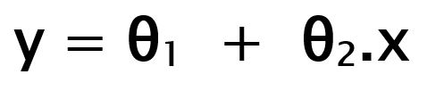

While training the model we are given : **x:** input training data (univariate – one input variable(parameter)) **y:** labels to data (Supervised learning) When training the model – it fits the best line to predict the value of y for a given value of x. The model gets the best regression fit line by finding the best θ1 and θ2 values. **θ1:** intercept **θ2:** coefficient of x Once we find the best θ1 and θ2 values, we get the best fit line. So when we are finally using our model for prediction, it will predict the value of y for the input value of x.

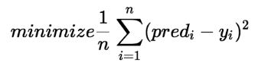

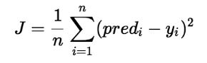

Cost function(J) of Linear Regression is the **Root Mean Squared Error (RMSE)** between predicted y value (pred) and true y value (y). [**Gradient Descent**](https://www.geeksforgeeks.org/gradient-descent-in-linear-regression/)**:** To update θ1 and θ2 values in order to reduce Cost function (minimizing RMSE value) and achieving the best-fit line the model uses Gradient Descent. The idea is to start with random θ1 and θ2 values and then iteratively updating the values, reaching minimum cost.

**Conclusion:** Hence we have created a Linear Regression Model to predict home prices using Boston Housing Dataset.